ooxWord://word/media/image1.pngooxWord://word/media/image3.png

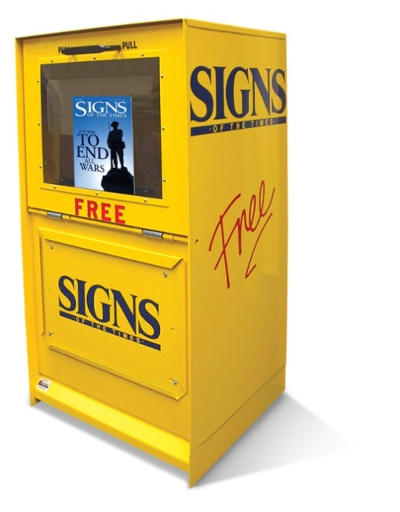

January 2021

Re: *Signs of the Time®* News box placement

To Whom It May Concern:

I am requesting permission to place a *Signs of the Time®* News box at the Publix supermarket located at ­­­­­_________. These news boxes have been in production since 1993 and offer free copies of

*Signs of the Times®*.

*Signs of the Times®* is a monthly magazine that helps readers understand Christianity and the impact it can have on their lives and society. The content appeals to people from all walks of life and includes articles on health, relationships, and Bible topics such as the second coming of Jesus Christ.

It is published in Nampa, Idaho by the North American Division of Seventh-day Adventists and has a circulation of over 75,000.

I’ve included a copy of the magazine for review. Thank you for considering my request.

Sincerely,

John Doe

Phone: (208) 465-2500 • Fax: (208) 465-2531 •[signs@pacifcpress.com](mailto:signs@pacifcpress.com)   
[Published by Pacifc Press® Publishing Association](mailto:signs@pacifcpress.com)•[P.O. Box 5353, Nampa, ID 83653-5353](mailto:signs@pacifcpress.com)